 | Visitor pack cea/icc
 | 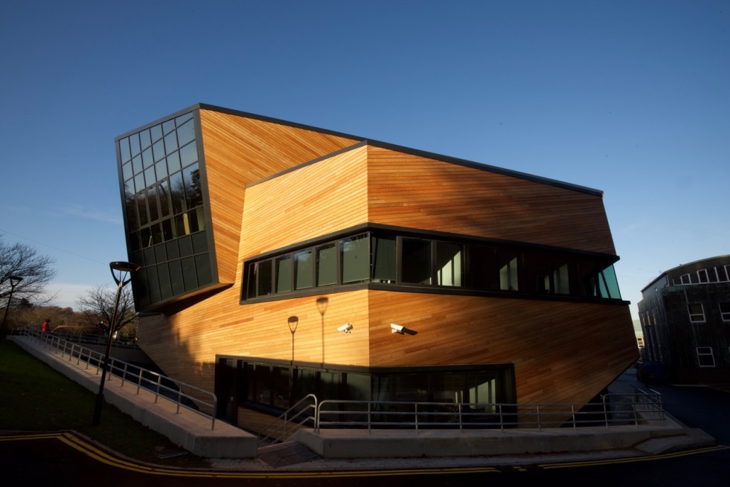
2023-2024 | Welcome
Dear Visitor
Welcome to Durham University’s Physics department. We hope the visitor pack will help you finding your way around Durham and the department and answer FAQ’s.
P1 – How to get to Durham University
P2 – Further useful information – wifi/visitor offices
P3 – Request for payment and instructions
P4 – Contacts / addresses

How to get to Durham

By road

Durham city centre is only two miles from the A1(M). Leave the motorway at Junction 62 on the A690 Durham - Sunderland road and follow signs to Durham City Centre.
Durham is 264 miles from London, 187 miles from Birmingham, 125 miles from Edinburgh and 67 miles from York.
There are several express coach services daily from most major cities. Durham is well served by both regional express services and the local bus network. From the city bus station - a short walk from the railway station - a bus service runs every 15 minutes past the Colleges on South Road.

By rail

60 InterCity trains from most major centres in the country call at Durham daily including 14 trains from London. The National Express high speed service takes under 3 hours from London King's Cross on the main East Coast line. First Transpennine Express offers frequent links to Manchester, Sheffield and Leeds, while Cross Country links Durham directly with Scotland, the Midlands, and the South West.

Durham is just over 3 hours from Birmingham, 2½ hours from Manchester, 1½ hours from Edinburgh and 45 minutes from York.

A taxi will take you from the station to the Science site in about 8 minutes, you will find them parked outside the rail station . You can walk to the city centre in 10 minutes. If you prefer to walk to the it will take you aroun 25mins.

By air

Durham is 40 minutes' drive from Newcastle Airport and about 40 minutes from Durham Tees Valley. Both have regular domestic and international flights. Durham is linked to Newcastle Airport by rail and metro. Travellers into Durham Tees Valley can take advantage of the free Sky Express bus service that links the airport to Darlington railway station, with regular connections to Durham.

By sea

Scheduled ferry services link the River Tyne to The Netherlands.

Taxi
We are happy to book a taxi for you but please give us plenty of time especially on a Friday afternoon during ‘the school run’. If you prefer to arrange your own taxi from/to the airport Sherburn’s taxis 0191/3723388. If you travel on a budget, you can look for airport express http://www.airport365.com/, they have booking and payment facilities.

Useful Information

Process
Before you arrive in Durham for a long term visit you will need to complete paperwork:

Visiting academics: Please see https://www.dur.ac.uk/hr/academicvisitors/
Visiting PhD students: Please get in touch with physics.postgraduate@durham.ac.uk
if you have questions please get in touch with astro.secretary@durham.ac.uk
In some cases you might need a visa, information see https://www.gov.uk/browse/visas-immigration

Wireless - TheCloud@Durham

Visitors and non-accademic guests should use ‘TheCloud@Durham’ to connect to the wireless service when visiting Durham University. Once all paperwork is in place you will receive an ITS username and campus card.

About “TheCloud”
‘TheCloud’ is a free public access wireless service with thousands of hotspots and millions of registered users, it provides simple, fast and reliable wireless Internet access

'TheCloud' service is available for Android, iOS, Windows and Mac devices.

Get Connected
To connect to ‘TheCloud@Durham’ simply follow the steps below:

1. Switch on your smartphone, tablet or other Wi-Fi device and check that Wi-Fi is enabled.
2. Select 'TheCloud@Durham' from the available network list
3. Open your Internet browser - 'TheCloud' landing page below will appear. Click 'Get Online'.
If the web page does not appear refresh the page or click here.
4. You will then see the service selection screen. Select ‘The Cloud Wi-Fi'.
5. Once this is done you can either login with an existing 'TheCloud' account, or click on the 'Create Account' button to register for a free account.
6. Once you have logged in or registered you will be able to access the Internet using 'TheCloud@Durham'.

Use of offices

We try to provide office space for our visitors. Please note that this is normally a desk of a member of staff or student who is away while you are here. Please keep it tidy, don’t move furniture around, just generally leave it as you have found it.

Coffee/tea/kitchen

On the first and second floor are kitchens with boiling water taps and Lavazza coffee makers. Please help yourself to a cup of tea or coffee, price as advertised. Visitor cups are in the cupboard, milk is in the fridge (glass bottles, whole milk, if you require soy milk please let us know) sugar and sweeteners are on the worktop. Please keep the kitchen clean (including the cup you are using)

Expenses

Request for payment

If we have agreed to pay for travel expenses and subsistence this can be claimed via the ‘Request for payment’ form. Note that you cannot claim for alcohol, room service, minibar, telephone costs, travel in 1st or business class or insurance.
Return the claim forms together with all receipts
by mail/email to
astro.secretary@durham.ac.uk
ICC/CEA, Department of Physics
Durham University
South Road
Durham, DH1 3LE
UK

Notes for completion:
1. For audit and financial regulations purposes full details of expenditure must be
provided. Any related documentation (receipts) should be attached to the form to support
the request. We don’t require boarding cards or passport copies. If you have booked your flight online, the receipt needs to include a price.
2. A cheque will be issued for all payments less than £1000.
3. Please provide current bank sort code and account number on the form where
payment over £1000 is required by bank transfer.
4. Overseas payments (payments to be made overseas regardless of currency) must include / have attached details of:
• Bank details: name, address, SWIFT code or BIC number, account number
(and IBAN for European Countries).
Account holder name
Name and private address of payee
If there is not enough space on the claim form, attach the details on a separate A4 sheet
5. The total sum needs to be in GBP for participants from UK, in Euro or USD for participants from overseas
6. The bank transfer (especially to overseas locations) can take two weeks and longer.
Please note that you don’t need to sign or complete the bottom part of the form (starting with ‘Expenditure Allocation’), in case of questions email astro.secretary@durham.ac.uk

Contacts

CEA – Center for Extragalactic Astronomy
Email: astro.secretary@durham.ac.uk
ICC – Institute for Computational Cosmology
Email: astro.secretary@durham.ac.uk

Durham University
Astronomy Group, Physics
South Road, Science Site
Durham DH1 3LE, UK

